**A REPORT ON COMPUTER SYSTEM**

**AND**

**BOOLEAN ALGEBRA**

Submitted to:Milan Baral

Prepared by: Krishna Khanal

Grade: XI

Section: R1

Roll.no: 12

**Acknowledgements**

I would like to extend my profound gratitude to my respected

Computer Science teacher ***Mr. Milan Baral*** who always encouraged me in my study and gave me the task to prepare

a report on Computer System and Boolean Algebra.

I am also profoundly grateful to ***Mr.Takanath Timalsina*** ,my maths teacher for giving me the advance concept on Boolean Algebra.I am also grateful to the other researchers whose works helped me by providing materials to present the report in this form.

I cannot forget the help rendered by my teachers and parents. I am also obliged to my classmates for their co-operation.

*Krishna Khanal*

Objective of the Study

* **To provide a comprehensive understanding of computer systems.**
* **To explain the working principles and characteristics of computers.**
* **​ To highlight various application areas of computers across different industries.**
* **To detail the historical development and generations of computers.**
* **To introduce and explain the types and functions of logic gates.**
* **To educate about Boolean algebra and its importance in digital electronics.**
* **To fulfill an academic requirement for the author’s studies.**
* **To enhance the knowledge of the author and readers in the field of computer science.**

**Chapter-1**

**1.Introduction to the Computer System**

**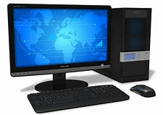**

A computer is an electronic device that processes data, performs calculations, and executes a wide range of tasks according to programmed instructions. It consists of hardware components, like the CPU (Central Processing Unit), memory, and storage, that work together to execute operations. Computers can handle various data types, including text, numbers, images, and sounds, making them versatile tools in fields ranging from science and business to entertainment and education. By running software, computers allow users to accomplish tasks like writing, drawing, managing data, and connecting to the internet, transforming how we work, communicate, and learn.

A computer system integrates cutting-edge hardware and sophisticated software to deliver high-speed processing, vast storage capabilities, and intelligent functionalities. Such systems often use **multi-core processors**, **solid-state drives (SSD)** for faster data access, and **advanced graphics processing units (GPUs)** that handle complex visual tasks, essential in areas like gaming, AI, and scientific research. Modern systems are also enhanced by **cloud computing** and **machine learning algorithms**, enabling real-time data analysis, automation, and predictive capabilities. Additionally, they support seamless connectivity across devices through networks like **5G** and **Internet of Things (IOT)**, allowing smart devices to interact with each other, creating a cohesive and powerful computing environment that drives innovation in nearly every industry.

* 1. **Working Principle of a Computer**

**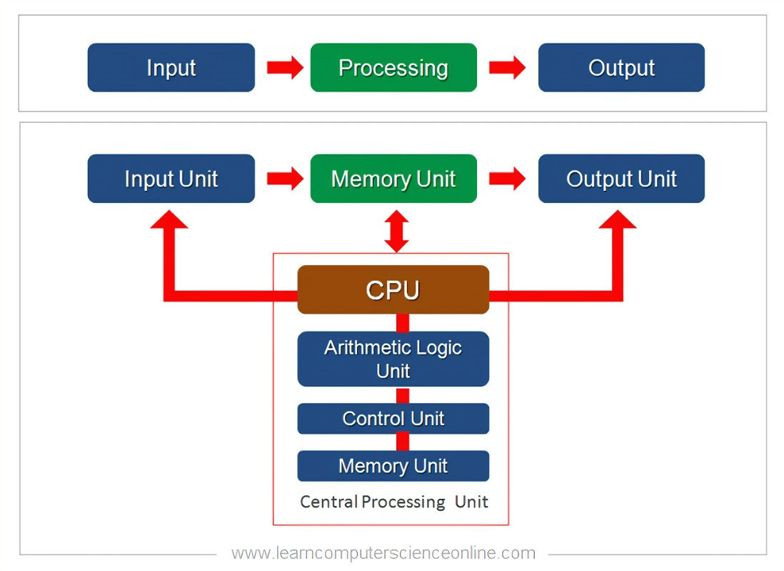**

The working principle of a computer follows a basic cycle known as the **IPO cycle** (Input, Process, Output), with the optional addition of **Storage**. Here’s how it works:

1. **Input**: The computer receives data and instructions from input devices like a keyboard, mouse, or scanner. This data is converted into a digital format that the computer can understand.
2. **Processing**: The Central Processing Unit (CPU) takes over, interpreting and executing instructions. The CPU performs arithmetic and logical operations, often assisted by specialized hardware like the GPU (Graphics Processing Unit) for tasks requiring complex calculations.
3. **Storage**: Data may be temporarily held in primary memory (RAM) for quick access or stored in secondary storage (like hard drives or SSDs) for long-term use. This allows the computer to retain information and recall it when needed.
4. **Output**: Once processed, the computer sends the results to output devices like monitors, printers, or speakers, displaying the final output in a human-readable format.

This cycle allows computers to process vast amounts of data quickly and accurately, following a precise sequence from input to final output. Advanced systems also incorporate **feedback loops**, where outputs can influence further inputs, allowing for more complex operations and automation.

* 1. Character

The main characteristics of a computer are what make it unique and effective for a variety of tasks. Here are the primary characteristics:

**1. Speed**

* Computers can process data and perform calculations incredibly quickly, often completing millions or billions of instructions per second.

**2. Accuracy**

* Computers provide a high degree of accuracy in processing data. Errors generally occur only due to human input mistakes or software issues, not due to the computer itself.

**3. Automation**

* Computers can perform a sequence of operations automatically after being programmed. This allows them to execute tasks repetitively without human intervention.

**4. Storage**

* Computers can store vast amounts of data. This storage capacity varies by device, but even personal computers can store a significant amount of information in various storage mediums like hard drives, SSDs, or cloud storage.

**5. Versatility**

* Computers are versatile and can be used for various purposes, from gaming to complex scientific computations, simply by changing software.

**6. Diligence**

* Unlike humans, computers can work continuously for long periods without getting tired or losing accuracy, making them ideal for repetitive tasks.

**7. Connectivity**

* Computers can connect to each other and form networks, enabling data sharing and communication over long distances, especially via the internet.

**8. Logical Decision Making**

* Through programming, computers can make logical decisions based on specific conditions, though they lack human-like reasoning and judgment.

These characteristics make computers essential in fields ranging from personal productivity to scientific research and industrial applications.

* 1. Application Areas of Computer

Computers have become essential tools across nearly every field, offering speed, accuracy, and the ability to handle vast amounts of data. They simplify complex tasks, automate processes, and provide solutions that were once time-consuming and labor-intensive. From personal finance management to scientific research and entertainment, computers are central to daily life and innovation. As technology advances, computers continue to play a vital role in developing fields like artificial intelligence and robotics. Below, we’ll explore some major application areas of computers, highlighting their impact across various industries.

### ****1.Education****

* Computers have transformed education by providing access to a wealth of resources and enabling innovative learning methods. Through online learning platforms, students can attend classes virtually, access a wide range of digital books, tutorials, and interactive tools. Computers allow teachers to use multimedia content to explain complex concepts, making lessons more engaging and accessible to diverse learning styles. They also facilitate assignments, research, and projects through tools like word processors, spreadsheets, and presentation software. Moreover, educational institutions use computers to manage student records, track progress, and maintain communication with parents and stakeholders, creating a cohesive educational environment.

### 2. ****Healthcare****

* In healthcare, computers are indispensable, supporting everything from patient care to hospital administration. Electronic Health Records (EHR) systems store and manage patient information, allowing healthcare providers to access medical history quickly, improving diagnosis and treatment. Advanced imaging systems, like MRIs and CT scans, rely on computers for precise results, enabling doctors to detect and treat conditions more accurately. Telemedicine, made possible by computers and the internet, allows patients to consult doctors remotely, which is especially beneficial for those in remote areas. Computers also aid in medical research by analyzing large datasets to develop treatments, track the spread of diseases, and streamline vaccine development.

### 3. ****Business and Finance****

* Businesses use computers to handle daily operations, data management, and strategic planning. In accounting, computers simplify complex financial calculations, track transactions, and generate financial reports, which helps businesses make informed decisions. Customer Relationship Management (CRM) software helps businesses understand customer needs, manage leads, and improve sales strategies. In finance, computers power online banking, mobile payment systems, stock trading platforms, and cryptocurrency exchanges. Advanced algorithms analyze financial trends, predict market movements, and provide insights that help investors and companies maximize profits and manage risks effectively.

### 4. ****Entertainment****

* The entertainment industry leverages computers for creating, editing, and distributing content. Advanced graphics and animation software enable filmmakers and game developers to produce visually stunning experiences. Virtual reality (VR) and augmented reality (AR) technologies, powered by computers, create immersive gaming environments and interactive experiences. Musicians use computers to record, mix, and produce music, while video editors craft movies, advertisements, and online content. Streaming services like Netflix and YouTube use algorithms to recommend personalized content to users, enhancing user engagement and satisfaction. Computers have thus expanded the reach and creativity of entertainment, making it more accessible and engaging.

### 5. ****Communication****

* Computers have revolutionized communication, making it faster, more accessible, and more versatile. With email, messaging apps, and video conferencing platforms, people can connect instantly across the globe. Social media networks like Facebook, Twitter, and Instagram allow people to share updates, photos, and videos, facilitating social connections and community building. Businesses use computers to improve customer support through live chat and automated responses. Advanced translation tools break down language barriers, enabling people from different linguistic backgrounds to communicate effectively. These technologies help bridge physical distances and enable global collaboration and personal connections like never before.

### 6. ****Research and Development****

* Computers are crucial in research and development across various scientific fields. Researchers use them to analyze vast datasets, run simulations, and perform experiments that would otherwise be time-consuming or impossible. In fields like genetics, computers analyze DNA sequences and study genetic diseases, contributing to advancements in personalized medicine. In physics and chemistry, computers simulate complex reactions and molecular structures, providing insights that drive innovations. Researchers also use data visualization tools to present findings clearly and meaningfully. By speeding up data analysis, simulations, and model testing, computers empower scientists to innovate faster and more accurately.

### 7. ****Manufacturing and Robotics****

* Computers are essential in modern manufacturing, where they control production processes, manage inventory, and coordinate logistics. Computer-aided manufacturing (CAM) systems automate repetitive tasks, reducing the need for human labor and enhancing precision. Robots, powered by computer algorithms, perform tasks like assembly, packaging, and quality control. These robots operate continuously with high accuracy, which increases production speed and reduces errors. Computers also help with predictive maintenance by monitoring machinery performance and identifying potential failures before they happen, minimizing downtime and repair costs. Thus, computers streamline manufacturing and contribute to safer, more efficient production.

### 8. ****Transportation****

* In the transportation sector, computers assist in managing traffic, scheduling flights, and navigating routes. GPS technology, powered by computer systems, guides drivers and travelers to their destinations efficiently. In aviation, air traffic control systems rely on computers to coordinate aircraft movements and ensure passenger safety. Railways and shipping companies use computers to optimize cargo movement and manage schedules. Ride-sharing platforms like Uber and Lyft connect passengers with drivers, making transportation more accessible. Additionally, computers are at the core of autonomous vehicle technology, which is expected to reshape the future of transportation by reducing accidents and improving mobility.

### 9. ****Engineering and Design****

* Engineers and architects use computers extensively in design and development. Computer-Aided Design (CAD) software allows them to create precise, detailed models of products, buildings, and structures before they are built. Computer-Aided Engineering (CAE) tools simulate stresses, material properties, and real-world conditions, helping engineers test prototypes and improve designs. These tools reduce the need for physical prototypes, saving time and costs in development. Advanced 3D modeling and simulations allow engineers to visualize projects from multiple angles and test the feasibility of their designs, leading to safer and more efficient products and structures.

### 10. ****Retail and E-commerce****

* Computers power the retail and e-commerce industries by enabling online shopping, digital marketing, and supply chain management. E-commerce platforms use data analysis tools to understand customer preferences, track shopping patterns, and suggest personalized recommendations. Retailers use inventory management systems to keep stock levels optimized and avoid overstocking or stockouts. Computers enable seamless online transactions and improve customer service through chatbots and personalized shopping experiences. Digital marketing strategies, powered by computers, target audiences more accurately, increasing sales and customer satisfaction. This technology allows businesses to reach a global audience and operate 24/7.

### 11. ****Science and Weather Forecasting****

* Computers play a crucial role in scientific research and weather forecasting. Meteorologists use computer models to predict weather patterns, track storms, and assess climate changes. Computers analyze vast amounts of atmospheric data from satellites, weather stations, and sensors, allowing scientists to forecast weather more accurately. These predictions help farmers plan agricultural activities, governments issue disaster warnings, and communities prepare for severe weather. Climate scientists also use computers to model long-term climate trends, aiding in studies of global warming and environmental protection. Computers thus contribute significantly to public safety and environmental awareness.

### 12. ****Banking and Insurance****

* In banking, computers handle millions of transactions, maintain customer data, and ensure account security. They streamline tasks such as online banking, fund transfers, and automated bill payments, making banking more convenient and secure. In insurance, computers assess customer profiles, calculate premiums, and manage claims. Algorithms analyze risks, helping insurers price their products accurately. Fraud detection systems in banking and insurance use advanced analytics to identify suspicious activities and reduce financial losses. Computers enhance customer service through online portals and automated support, making financial services more accessible and user-friendly.

### 13. ****Defense and Military****

* Computers are vital in defense and military operations, providing tools for intelligence, surveillance, and cyber defense. Modern military equipment, like drones and missile systems, uses computer algorithms for guidance and targeting. Computers assist in training through simulations and virtual reality, preparing soldiers for real-world scenarios without actual risks. Cybersecurity in the military relies on computer systems to protect sensitive data and prevent cyber-attacks. Computers also coordinate logistics, resource management, and communication within the armed forces, making operations more efficient and secure.

**Chapter-2**

**2.Histroy and Generation of Computer**

We’ve come a long way since the first generation of computer, with new generation of computers bringing significant advances in speed and power to computing tasks. Learn about each of the five generations of computers and major technology developments that have led to the computer technology that we use today.

The history of[computer](https://www.webopedia.com/definitions/computer/" \t "_blank) development is a computer science topic that is often used to reference the different generations of computing[devices](https://www.webopedia.com/definitions/device/" \t "_blank). Each computer generation is characterized by a major technological development that fundamentally changed the way computers operate.

Each major developments from the 1940s to the present day (5th generation of computer) has introduced smaller, cheaper, more powerful, and more efficient computing machines. This technology has minimized storage and increased portability.

**2.1 Five Generations of Computer**

**1.First Generation: Vacuum Tubes (1940–1956)**

The first generation of [computer systems](https://www.webopedia.com/definitions/computer-system/" \t "_blank) used vacuum tubes for circuitry and[magnetic drums](https://www.webopedia.com/definitions/magnetic-drum/" \t "_blank) for main[memory](https://www.webopedia.com/definitions/memory/" \t "_blank), and they were often enormous, taking up entire rooms. These computers were very expensive to operate, and in addition to using a great deal of electricity, the first computers generated a lot of heat, which was often the cause of malfunctions. The maximum internal storage capacity was 20,000 characters.

First generation computers relied on[machine language](https://www.webopedia.com/definitions/machine-language/" \t "_blank), the lowest-level[programming language](https://www.webopedia.com/definitions/programming-language/" \t "_blank) understood by computers, to perform operations, and they could only solve one problem at a time. It would take operators days or even weeks to set up a new problem. Input was based on punched cards and paper tape, and output was displayed on printouts.

It was in this generation that the Von Neumann architecture was introduced, which displays the design architecture of an electronic digital computer. Later, the UNIVAC and[ENIAC](https://www.webopedia.com/definitions/eniac/" \t "_blank) computers, invented by J. Presper Eckert, became examples of first generation computer technology. The UNIVAC was the first commercial computer delivered to a business client, the U.S. Census Bureau in 1951.

## **2.Second Generation: Transistors (1956-1963)**

The world would see[transistors](https://www.webopedia.com/definitions/transistor/" \t "_blank) replace vacuum tubes in the second generation of computer. The transistor was invented at Bell Labs in 1947 but did not see widespread use in computers until the late 1950s. This generation of computers also included hardware advances like magnetic core memory, magnetic tape, and the magnetic disk.

The transistor was far superior to the vacuum tube, allowing computers to become smaller, faster, cheaper, more energy-efficient, and more reliable than their first-generation predecessors. Though the transistor still generated a great deal of heat that subjected the computer to damage, it was a vast improvement over the vacuum tube. A second-generation computer still relied on punched cards for[input](https://www.webopedia.com/definitions/input/" \t "_blank) and printouts for[output](https://www.webopedia.com/definitions/output/" \t "_blank).

**3.Second Generation: Integrated Circuits (1964-1971)**

The development of the[integrated circuit](https://www.webopedia.com/definitions/integrated-circuit-ic/" \t "_blank) was the hallmark of the third generation of computers. Transistors were miniaturized and placed on[silicon](https://www.webopedia.com/definitions/silicon/" \t "_blank)[chips](https://www.webopedia.com/definitions/chip/" \t "_blank), called[semiconductors](https://www.webopedia.com/definitions/semiconductor/" \t "_blank), which drastically increased the speed and efficiency of computers.

Instead of punched cards and printouts, users would interact with a third-generation computer through[keyboards,](https://www.webopedia.com/definitions/keyboard/" \t "_blank)[monitors,](https://www.webopedia.com/definitions/monitor/" \t "_blank)and[interfaces](https://www.webopedia.com/definitions/interface/" \t "_blank) with an[operating system](https://www.webopedia.com/definitions/operating-system/" \t "_blank), which allowed the device to run many different[applications](https://www.webopedia.com/definitions/application-software/" \t "_blank) at one time with a central program that monitored the memory. Computers, for the first time, became accessible to a mass audience because they were smaller and cheaper than their predecessors.

**4.Fourth Generation: Microprocessor(1971-Present)**

The[microprocessor](https://www.webopedia.com/definitions/microprocessor/" \t "_blank) ushered in the fourth generation of computers, as thousands of integrated circuits were built onto a single silicon chip. The technology in the first generation that filled an entire room could now fit in the palm of the hand. The Intel 4004 chip, developed in 1971, integrated all the components of the computer, from the[central processing unit](https://www.webopedia.com/definitions/cpu/" \t "_blank) and memory to input/output controls, on a single chip.

In 1981,[IBM](https://www.webopedia.com/definitions/ibm/" \t "_blank) introduced its first personal computer for the home user, and in 1984[Apple](https://www.webopedia.com/definitions/apple-computer/" \t "_blank) introduced the Macintosh. Microprocessors also moved out of the realm of[desktop computers](https://www.webopedia.com/definitions/desktop-computer/" \t "_blank) and into many areas of life as more and more everyday products began to use the microprocessor chip.

As these small computers became more powerful, they could be linked together to form networks, which eventually led to the development of the Internet. Each fourth-generation computer also saw the computer development of[GUIs](https://www.webopedia.com/definitions/gui/" \t "_blank), the[mouse](https://www.webopedia.com/definitions/mouse/" \t "_blank), and[handheld](https://www.webopedia.com/definitions/hand-held-computer/" \t "_blank) technology.

**5.Fifth Generation: Artificial Intelligence(Present and Beyond)**

The fifth generation of computer technology, based on artificial intelligence, is still in development. However, there are some applications, such as[voice recognition](https://www.webopedia.com/definitions/voice-recognition/" \t "_blank), that are being used today. The use of[parallel processing](https://www.webopedia.com/definitions/parallel-processing/" \t "_blank) and superconductors is helping to make artificial intelligence a reality. This is also so far the prime generation for packing a large amount of storage into a compact and portable device.

[Quantum computation](https://www.webopedia.com/definitions/quantum-computing/" \t "_blank) and molecular and[nanotechnology](https://www.webopedia.com/definitions/nanotechnology/" \t "_blank) will radically change the face of computers in years to come. The goal of fifth-generation computing is to develop devices that will respond to[natural language](https://www.webopedia.com/definitions/natural-language/" \t "_blank) input and are capable of learning and self-organization.

**Chapter-3**

**3.Logic Gates**

Logic gates are the fundamental components of all digital circuits and systems. In digital electronics, there are seven main types of logic gates used to perform various logical operations. A logic gate is basically an electronic circuit designed by using components like diodes, transistors, resistors, capacitors, etc., and capable of performing logical operations.

**3.1 Types of Logic Gates**

The logic gates can be classified into the following major types:

### ****1. Basic Logic Gates****

There are three basic logic gates:

1. AND Gate
2. OR Gate
3. NOT Gate

### ****2. Universal Logic Gates****

In digital electronics, the following two logic gates are considered as universal logic gates:

1. NOR Gate
2. NAND Gate

### ****3. Derived Logic Gates****

The following two are the derived logic gates used in digital systems:

1. XOR Gate
2. XNOR Gate

**Lets dive into the advance concept of logic gates:**

**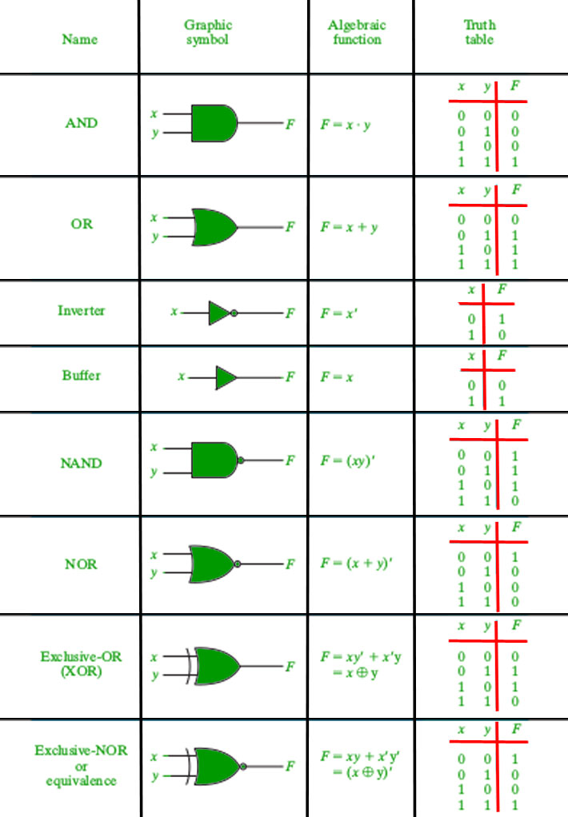**

**Chapter-4**

**4.Boolean Algebra**

Boolean algebra is a type of algebra that is created by operating the binary system. In the year 1854, George Boole, an English mathematician, proposed this algebra. This is a variant of Aristotle’s propositional logic that uses the symbols 0 and 1, or True and False. Boolean algebra is concerned with binary variables and logic operations.

Boolean Algebra is fundamental in the development of digital electronics systems as they all use the concept of Boolean Algebra to execute commands. Apart from digital electronics this algebra also finds its application in Set Theory, Statistics, and other branches of mathematics.

**4.1 Basic laws of Boolean Algebra**

The main use of boolean algebra is in simplifying logic circuits. By applying Boolean algebra laws, we can simplify a logical expression and reduce the number of logic gates that need to be used in a digital circuit. Some of the important boolean algebra laws are given below:

### Distributive Law

The distributive law says that if we perform the AND operation on two variables and OR the result with another variable then this will be equal to the AND of the OR of the third variable with each of the first two variables. The boolean expression is given as

A + B.C = (A + B) (A + C)

Thus, OR distributes over AND

If we OR two variables then AND their result with another variable then this value will be equal to the OR of the AND of the third variable with the other two variables. This is given by:

A .(B+C) = (A.B) + (A.C)

Hence, AND distributes over OR.

### Associative Law

According to the [associative law](https://www.cuemath.com/numbers/associative-property/), if more than two variables are OR'd or AND'd then the order of grouping the variables does not matter. The result will always be the same. The expressions are given as:

A + (B + C) = (A + B) + C

A.(B.C) = (A.B).C

### Commutative Law

[Commutative law](https://www.cuemath.com/numbers/commutative-property/) states that if we interchange the order of operands (AND or OR) the result of the boolean equation will not change. This can be represented as follows:

A + B = B + A

A.B = B.A

### Absorption Law

Absorption law links binary variables and helps to reduce complicated expressions by absorbing the like variables. There are 4 statements that fall under this law given as:

* A + A.B = A
* A (A + B) = A
* A + Ā.B = A + B
* A.(Ā + B) = A.B

**De Morgan’s Law**

De Morgan’s laws are fundamental principles in set theory and boolean algebra. They are attributed to the British mathematician and logician Augustus De Morgan.

In set theory, the laws establish the relations between union, intersection, and complements of sets, while in Boolean algebra, they relate the operations of conjunction (AND, denoted by ∧), disjunction (OR, denoted by ∨), and negation or complement (NOT, denoted by ¬).

**Summary**

**The document, prepared by Krishna Khanal, provides an extensive overview of computer systems, their history, logic gates, and Boolean algebra.**

**It begins with an introduction to computer systems, describing them as electronic devices that process data and perform tasks using hardware components like the CPU, memory, and storage.**

**​**

**The working principle of computers follows the IPO cycle (Input, Process, Output) with optional storage, and they are characterized by speed, accuracy, automation, storage capacity, versatility, diligence, connectivity, and logical decision-making.**

**​ The document highlights various application areas of computers, including education, healthcare, business, entertainment, communication, research, manufacturing, transportation, engineering, retail, science, banking, and defense.**

**It then delves into the history and generations of computers, detailing the evolution from the first generation using vacuum tubes to the fifth generation focusing on artificial intelligence.**

**​ The third chapter covers logic gates, fundamental components of digital circuits, explaining the types and functions of basic, universal, and derived logic gates.**

**The final chapter introduces Boolean algebra, a mathematical approach using binary variables and logic operations, essential for simplifying logic circuits in digital electronics.**

**​ Key Boolean algebra laws such as distributive, associative, commutative, absorption, and De Morgan’s laws are discussed, emphasizing their importance in reducing the complexity of logical expressions.**

Refrences

1. **"Computer System Architecture" by M. Morris Mano**
2. "Digital Design" by M. Morris Mano
3. Introduction to Computer Systems" by Yale N. Patt and Sanjay J. Patel
4. "Discrete Mathematics and Its Applications" by Kenneth H. Rosen
5. "Digital Fundamentals" by Thomas L. Floyd
6. “Logic and Computer Design Fundamentals" by M. Morris Mano and Charles R. Kime
7. "Modern Digital Electronics" by R.P. Jain